
World Cup at Diefenbaker

Friday, June 12th
9 am to 2:45 pm

Students are invited to dress in their team colour and dress comfortably and appropriately for the weather (red, yellow, green or blue).

In case of rain weather, decision will be made and announced by 7 am on our school website, by email and School Messenger phone text. Rainout day will be on Monday, June 15th, depending on the weather.
Shape of the Day

8:20 | Grade 7 student leaders set up stations on the field
8:40 | Primary Bike Parade – bike drop off on the basketball court  See the grade zones for bike drop off on the basketball court.  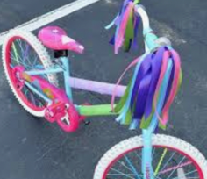 | - Decorate your bike  - No e-bikes allowed  - No e-scooters allowed  - Students MUST wear a helmet to participate on their bikes and scooters  - Bikes must be tested and be good to ride, check that tires are pumped.
8:50 | Attendance in the classroom.
9:05 | Parade participants called over PA to go outside and get ready | 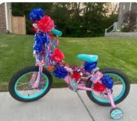
9:15 | All divisions called on the PA system to come to the field.  K-3 PRIMARY BIKE PARADE – one lap on the path around the school  Students return to their classrooms. | Drop off bikes in the multi after the parade  Order of the parade:  Grade 1  Kindergarten  Grade 2  Grade 3
9:25 | Students called on the PA system to assemble outside with their Bulldog team at their station number and colour
9:45 | ROTATIONS #1 to #4  15 min per rotation  #1 9:45 – 10 am  #2 10 – 10:15 am  #3 10:15 – 10:30 am  #4 10:30 – 10:45 am | Listen to music and siren for rotation change.
10:45 | Refreshment Break – frozen yogurt. Students need to bring clearly labelled water bottle outside.  PRESCHOOL RACE in the middle of the field | Thank you to our PAC for providing students with snacks: Frozen yogurt.
11:00 | ROTATIONS #5 to #8  15 minutes per rotations  #5 11:00 - 11:15 am  #6 11:15 – 11:30  #7 11:30 – 11:45  #8 11:45 – 12 pm
12:00 | Station clean-up – return to class for lunch
12:10 | Lunch: Sushi Lovers Hot Lunch  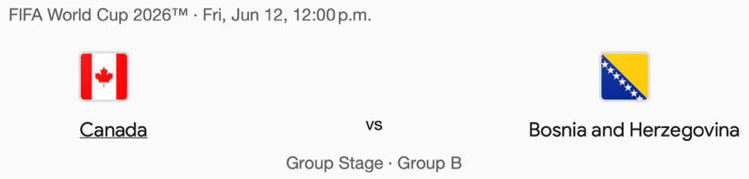  Will be delivered to classrooms as usual.  Canada game will be streamed in the gym for students interested in watching | Students can eat in the classroom or outside on this day.  Students can eat outside with their parents only.  Students only can eat in their classroom. Parents are welcome to eat with their students outside.  If you leave early, please let the office know.
1:00 | Watch second half of Canada's game | Teachers have the choice to bring their class to the gym to watch the second half of the game.
≈2:00 | TUG-OF-WAR outside on the field for students ONLY.  Gr. 7 Penalty Shoot-out | Tug of war order:  5, 3, 4, 2, K, 1, 6, 7
≈2:20 | Litter clean-up on field and return to classes
2:45 | Dismissal

