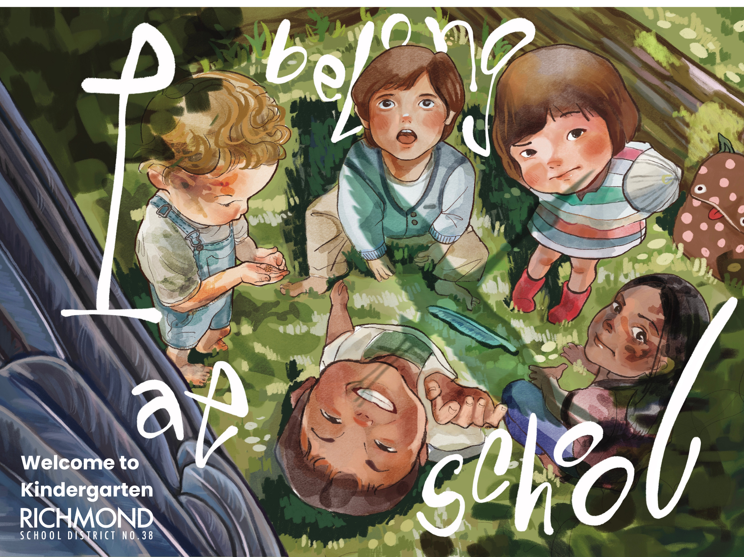
All students attend:
8:45 - 10:45 am
(bring recess snack)

Drop off and pick up at outside door # 3.

Group A attends:
8:45 - 9:45 am

Group B attends:
10:15 - 11:15 am

Drop off and pick up at outside door # 3.

Family Welcoming Conversations: Sept. 15-16, 2026
All families are invited to a 15 minute Welcoming Conversation with the Kindergarten Teacher. The purpose of this conversation is to learn more about each student from a family’s point of view. Please return the Getting to Know Your Child form on Tues, Sept 8th.

What Does Gradual Entry Look Like?
Children and their family will have opportunities to connect with their teachers and other key staff members during the first week of school. Your child will attend in either Group A or Group B. In the second week of school, children gradually attend over the lunch period and by Thursday, all children attend a full day.

Gradual Entry

Complete

FULL DAY
Regular School Schedule
In Effect

8:45 - 2:45 pm
(bring recess
snack and lunch)

ALL students attend
FULL DAY KINDERGARTEN

8:45 - 2:45 pm
(bring recess snack
and lunch)

All students attend:
8:45 - 12:15 pm
(bring recess
snack and lunch)

Welcoming
Conversations

All students attend:
8:45 - 11:30 am
(bring recess snack)

Welcoming
Conversations
All students attend:
8:45 - 11:15 am
(bring recess snack)

Friday, Sept. 18
Thursday, Sept. 17
Wednesday, Sept. 16
Monday, Sept. 14
Tuesday, Sept. 15
First Day of School

Kindergarten students come for 60 minutes

Everyone attends: 1:00 – 2:00

*Return Getting to Know Your Child form

Drop off and pick up at outside door # 3.

Group A:
8:45 - 11:15 am
(bring recess snack)
Group B:
12:15 - 2:45
(bring recess snack)

Drop off and pick up at outside door # 3.

Wednesday, Sept. 9
Tuesday, Sept. 8
Friday, Sept. 10
Thursday, Sept. 10

