JG Diefenbaker PAC Meeting

November 24, 2021

6.30 PM to 8.00 PM

6.32 call to order

Minutes: Motion to approve: Anney

Motion Seconded by: Emi

|  |  |
| --- | --- |
| Attendees: | Emi emieck@yahoo.ca |
| Huey | Angela |
| Melissa | Yuehen Ding |
| Nicole | Mimi Matsuo |
| Andrew |  |
| Kelly |  |
| Tressa tressa_kutny@hotmail.com |  |
| Maki Ode |  |
| Anney hianney@gmail.com |  |
| Jenna and Tim McCann |  |
| Kelvin |  |

**Admin report:**

1.It’s been a busy month (with some “firsts”) and we continue to adjust to learning and playing together in larger groups:

-the kids of Diefenbaker didn’t especially love the inside time on the first inside day in years.

-Halloween parade and Remembrance Day virtual Assembly on Nov. 10th went well (nice to see the students engage in thoughtful reflections and presentations)

-handwashing lessons from Kelly Simmons and UBC Nursing students tomorrow

-intramurals for Grade 6 and 7 students at lunch times

-student leaders in various roles have been a big help!

-Kindness Survey last week to see how our school goal is progressing; students asked to rate level of kindness in their classroom and around the school. Focus this year is to make a connection between kind acts and their learning.

2. Kindness to Others Initiatives: Sole-darity happening now and Holiday Hampers will start Dec. 1st.

3. Bollywood Dance program scheduled for all classes Dec. 6 – 10th. Performances will be recorded and then sent home to families. *Request for financial support from PAC for $2 per student.* Students will then pay $10 for the week-long workshop.

4. Classes continue to work hard; traditional term 1 report cards for Div. 1, 2, 5, 6, 7, 8, 9, 12 and 13 will go home Dec. 10th. All other classes are using the e-Portfolios for communicating student learning, and ALL students will have e-portfolios with at least Core Competencies posts in them. Logon information will be sent home with report cards.

A reminder for parents to contact teachers with any concerns/questions. Regular communication is helpful for student success and growth.

5. Online Kindergarten registration began Nov. 1st in the District. Applications for District Option Programs (French Immersion, LFI and Montessori) are accepted from Nov. 1st – Jan. 21st. LFI 6 presentations will hopefully take place in January and help increase our LFI numbers.

**Diefenbaker PAC Budget 2021-2022:**

Projected Income (Conservative estimate)

Motion to approve: Angela

Second: Emi

All approved (do execs and admin count?)

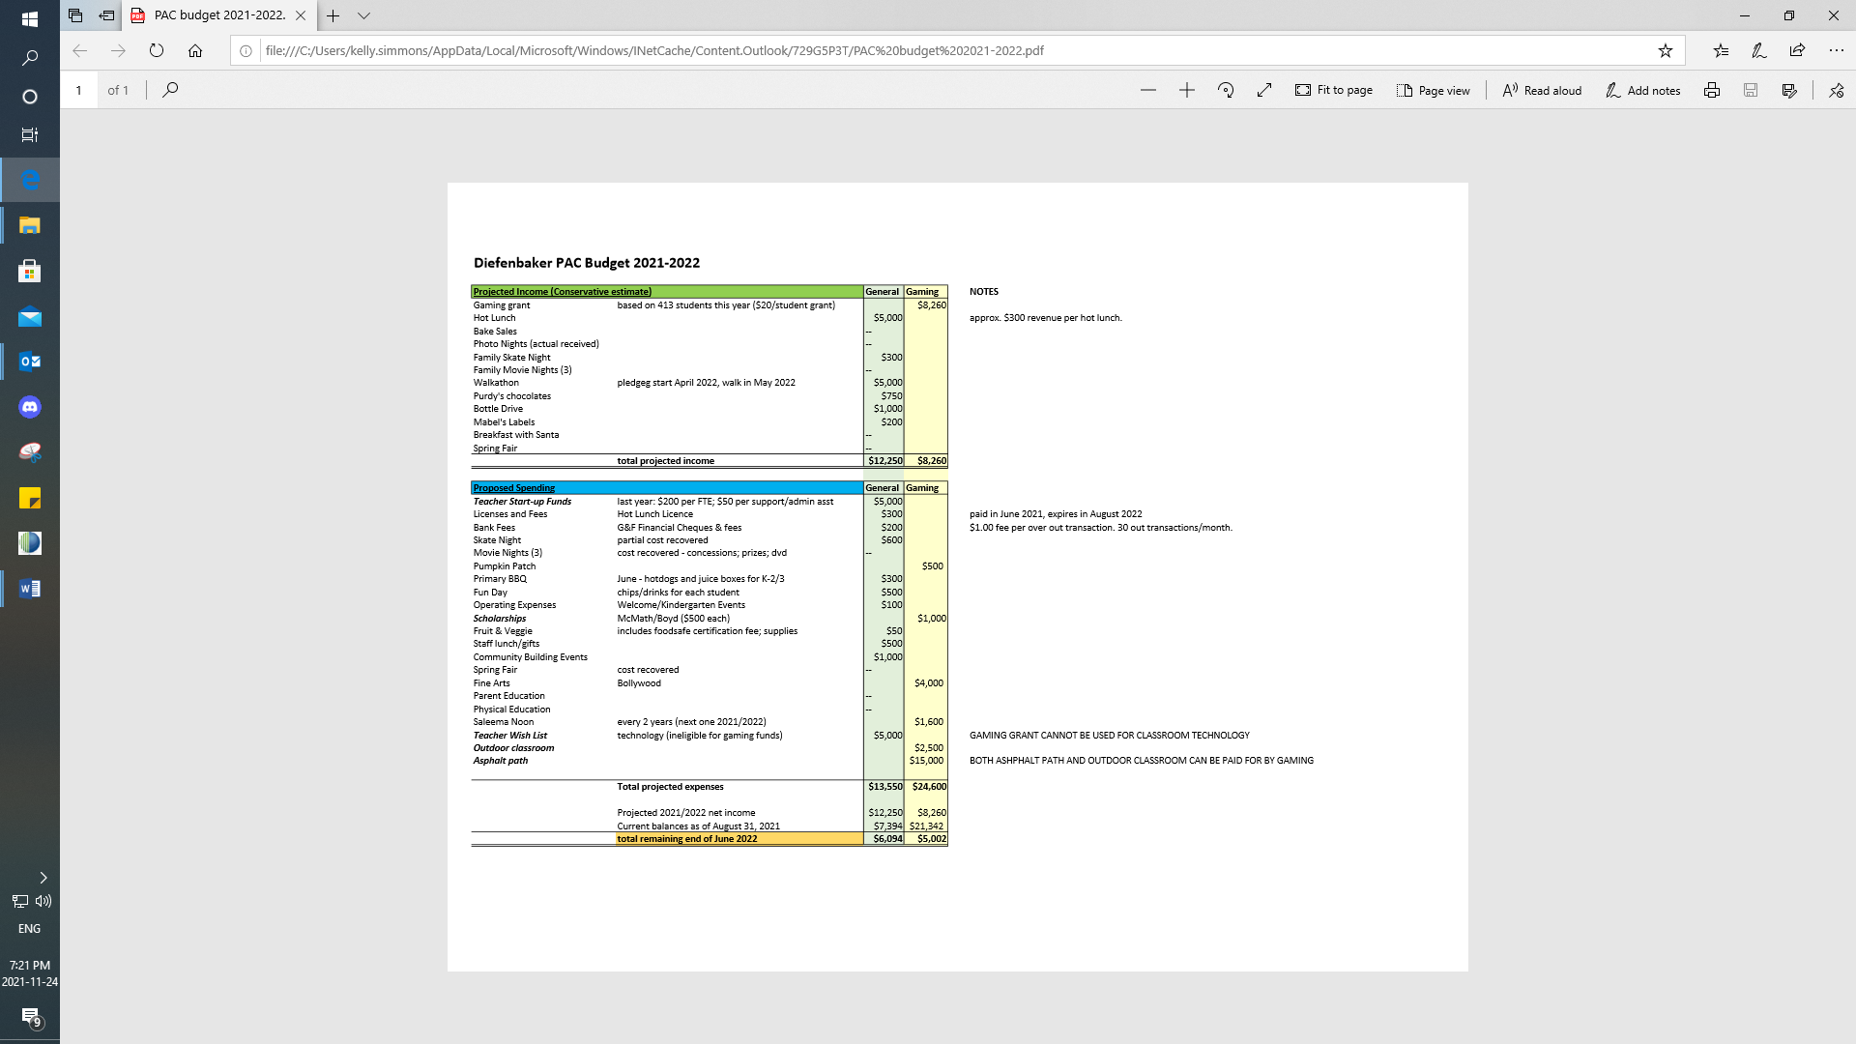

**Treasurers report:**

November 2021:

**PAC Report:**

Family skate night:

Cost to PAC is $600 and skaters capped at 150 therefore profit approximately 300. Will be a concession run by us that will offer pizza, popcorn and possibly hot chocolate, drinks. (looking for volunteers to run concession let Mel and Nic know). Possibly a wine auction?

December event:

Hot chocolate delivery as a community building activity. Each class. Needs volunteers. Let Nicole and Mel know. Admin on board. Focus on diversity/inclusion ie. maybe not elves. Dress up in winter clothing?

Coordinators report:

Milk delivery d/c’d remainder of year

Fruit and veggie will continue as is

Meeting adjourned at 1946

**Next meeting January 27 at 6.30 via Zoom**