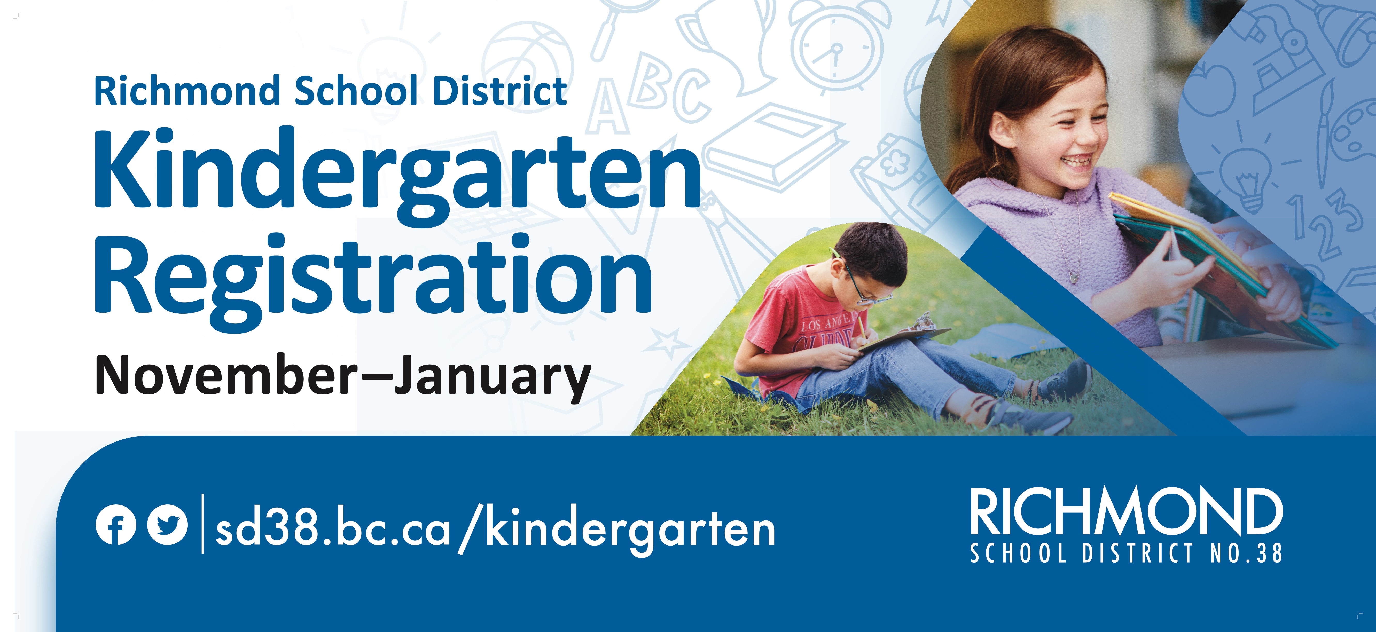

The Richmond School District 38 is excited to welcome **Kindergarten registration applications for children born in 2019, turning 5 in 2024**. These children will begin Kindergarten in September 2024. Online registration opens on November 1, 2023. Please visit our website [www.sd38.bc.ca/kindergarten](http://www.sd38.bc.ca/kindergarten) for more information about our online registration process, required documents, important dates, and FAQs.

We encourage families to complete their registration within the Priority 1 registration window, which spans from **November to January**, in order to maximize their chances of securing a spot at their catchment school. All registration applications received any time during the Priority 1 registration period will receive placement decisions by February 2, 2024.

Videos detailing Kindergarten registration have been made available on our District website, providing new parents with guidance on the registration process, English Language Learner (ELL) assessments, and District Program Options (Early French Immersion and Montessori). These videos are available in English and Mandarin. Please view the videos at [www.sd38.bc.ca/kindergarten](http://www.sd38.bc.ca/kindergarten).

Finally, there will be a **Kindergarten Information Evening for parents of students with disabilities and diverse abilities** on Zoom held on November 8th from 6:30 – 7:30pm. A link to the Zoom is available on our District website [www.sd38.bc.ca/kindergarten](http://www.sd38.bc.ca/kindergarten).

Thank you and please share this information with your friends and family who have Kindergarten aged children!