Tropical Paradise Fun Day at Diefenbaker



Friday, June 7th
9 am to 1:45 pm

Students are invited to dress in their team colour and dress comfortably and appropriately for the weather (red, yellow, green or blue).

In case of rain weather, decision will be made and announced by 7 am on our school website, by email and School Messenger phone text.
Rain out day will on Monday, June 10th, depending on the weather.

Shape of the Day

8:20 | Grade 7 student leaders set up stations on the field
8:40 | Bike Parade – bike drop off on the basketball court  See the grade zones for bike drop off on the basketball court. | - Decorate your bike in the tropical paradise theme  - No e-bikes allowed  - No e-scooters allowed  - Students MUST wear a helmet to participate on their bikes and scooters  - Bikes must be tested and be good to ride, check that tires are pumped.  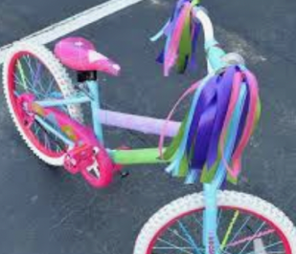
8:50 | Attendance in the classroom.
9:05 | Parade participants called over PA to go outside and get ready | 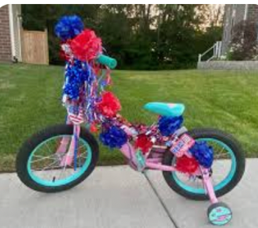
9:15 | BIKE PARADE – one lap on the field path  Order of the parade:  Each group will go ONE lap around the field path:  K/1 and 1/ 2  2/ 3 and 3/4  Students return to their classrooms. | Drop off bikes in the gym after the parade
9:25 | Students called on the PA system to assemble outside by Team/# cones with their Bulldog teams
9:45 | ROTATIONS #1 to #4  15 min per rotation  #1 9:45 – 10 am  #2 10 – 10:15 am  #3 10:15 – 10:30 am  #4 10:30 – 10:45 am | Listen to music and siren for rotation change.
10:45 | Refreshment Break – frozen yogurt. Students need to bring clearly labelled water bottle outside.  PRESCHOOL RACE in the middle of the field | Thank you to our PAC for providing students with snacks: Frozen yogurt.
11:00 | ROTATIONS #5 to #8  15 minutes per rotations  #5 11 -11:15 am  #6 11:15 – 11:30  #7 11:30 – 11:45  #8 11:45 – 12 pm
12:00 | Station clean up – return to class for lunch
12:10 | Lunch: Dairy Queen Hot Lunch  Will be delivered to classrooms as usual. | Students can eat in the classroom or outside on this day.  Students can eat outside with your parents only.  Students only in the classroom. Parents will eat with their students outside.  If you leave early before 1:45 pm, please let the office know.
12:45 | TUG-OF-WAR outside on the field for students ONLY.
12:55 | Litter clean-up on field  Tug of war order:  5, 3,4, 2, K, 1, 6, 7.
1:45 | Dismissal

