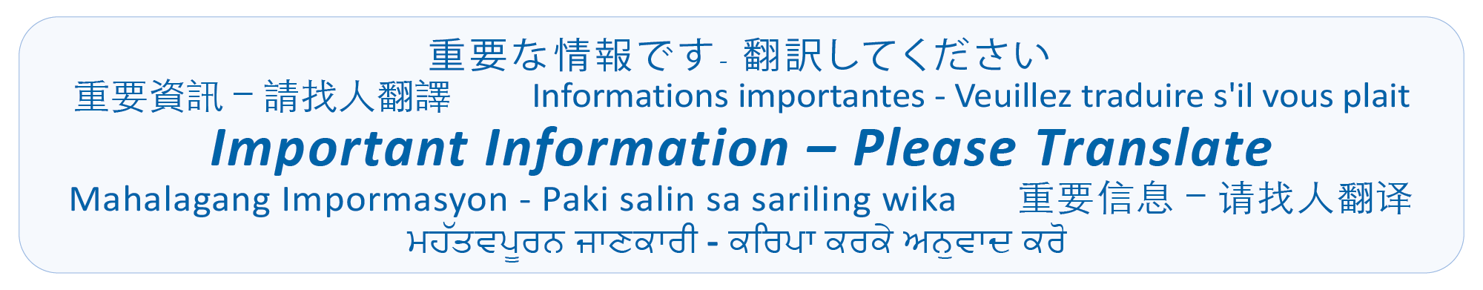 June 2026

Dear Kindergarten Caregiver(s),

Diefenbaker School welcomes you and your child. This letter will provide you with important information about your child’s upcoming Kindergarten Gradual Entry Schedule and Welcoming Conversation.

Starting Kindergarten is an important time for your child, your family, and school. For this reason, the Ministry of Education and Child Care and the Richmond School District have a gradual entry process to ensure that we get to know your child and create a sense of belonging as they transition to school. During the gradual entry process, we will have a Welcoming Conversation with each family.

Attached to this letter is your child’s gradual entry schedule for the first two weeks of school. You and your child will be invited to attend a 15-minute Welcoming Conversation, during which you will be able to share information about your child with the kindergarten teacher. The information you share with the teacher will be helpful in supporting your child throughout the year. Please fill out the attached Welcoming Conversation Child Interview Form before your visit and bring it with you. If required, a hard copy will be available at your child’s school in the first week of September. We have also included possible prompts for discussion during your Welcoming Conversation on the next page called Welcome to Kindergarten Conversation Starters.

Each child entering Kindergarten is a unique individual and gradual entry along with the Welcoming Conversations are essential for creating the foundation of support among the family, school and child.

We look forward to welcoming you and your child into our school community.

Sincerely,

Ms. Vosahlo, Principal

Welcome to Kindergarten Conversation Starters

Child’s Name
General Development | Please share information about:  - Your child’s early learning experiences.  Example: name of preschool, childcare, StrongStart, playgroups, dance/ sports, and any other programs they have attended  - Your child’s overall health including any medical conditions that may affect learning.
Physical Development | - How would you describe your child’s ability to use their hands for tasks like cutting with scissors, drawing, painting, etc.?  - Is your child independent using the toilet?  - Is your child able to dress independently (e.g. Put on own shoes and coat)?
Language Development | - What are some things your child likes to talk about?  - What are some of your child’s favourite books?  - How would you describe your child’s ability to follow directions?
Social-Emotional Development | - Describe your child’s personality.  - Are there situations, places, or times (e.g., loud noises, bright lights, crowds of people, etc.) when your child becomes upset, anxious, or excited? How do they react? What helps?
Favourite Activities | - What are your child’s favourite activities?

